Northern Shenandoah Valley Master Gardener Association
Warren County Government Center, Warren County
November 16, 2014
President Bob Carlton brought the meeting to order at 2:05 p.m.
October Meeting Minutes: Suzanne Boag noted that the October Association Meeting Minutes had been circulated to the membership, and she asked for any changes or corrections. Mary Craig made a motion to accept the minutes as circulated, and Rich Howell seconded it. The membership voted to accept the minutes as circulated with no objections.
Treasurer’s Report: Lee Demko presented the report as follows:
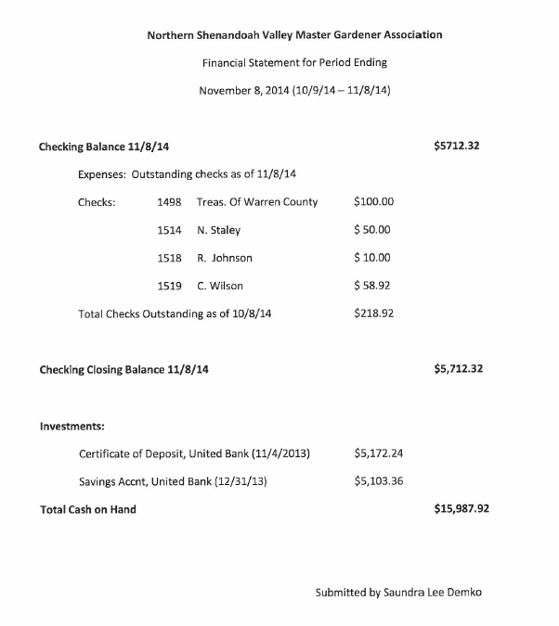
Committee Reports
Communications and Publicity: Helen Lake announced that a strategic planning workshop was held from 8 a.m. to 3:30 p.m. on October 25 at the Warren County Admin Building, Front Royal. Attending members agreed that is was time well spent. The group arrived at a set of one-year goals which will be presented to the new Board members at the January Board meeting for review.
Education: Helen Lake reviewed the events covered for the year were a public speaking workshop, Garden in the Valley Symposium, and strategic planning workshop. On November 13 awards for Jr. Master Gardeners were given. Twelve instructors and helpers from Frederick, Warren, and Shenandoah County participated in the class that started in January. The school presented gloves to the MG participants. Brenda Powell will be the new chair for this committee.
Finance: No report.
Membership: We have 86 active members. All Frederick County interns are now members.
Newsletter: Richard Stromberg is editor. Bob Carlton acknowledged that we have one of the better newsletters available.
County Coordinators’ Reports
Clarke: Mary Craig reported that their final county meeting was held prior to this meeting. She will be stepping down as County Coordinator. She advised that Blandy has offered our organization the opportunity of managing a community garden at their location. Portion of food grown will be donated. Each year the interns could be involved, and field trips could be given here. Mary will ask for a description of what is being offered: We have a couple of months to decide to accept this offer.
Frederick: Emily Wickham reported that a computer class will be offered to Master Gardeners which will cover search engines, e-mail, and VMS. Ten students have signed up: five for Frederick, four for Shenandoah, and one for Warren. Another class will be held if there’s interest. Greenline being monitored from home by Elizabeth Bevan. Over 200 contacts were made this year. An appreciation holiday dinner is scheduled for December 11 which will include Santa Claus. Frederick County is considering a brown-bag lunch during the week which will include a 45-minute presentation. In April they will be participating in Girl Scout Badge Day.
Page: Charles Newton reported that there is a person who will be transferring into their county’s group.
Shenandoah: The Greenline will be staffed through the winter by Greenline leaders. The county worked with over 200 kids this year, and nine members worked with the rain garden. There will be one more fall cleanup. They made 210 contacts at the Woodstock Farmers Market which has been very successful. The Strasburg Farmers Market was only held twice. At the VCE 100th anniversary, five members worked, and they made 11 contacts. The weather interfered with a good turnout. At the Shenandoah Co. Fair, 150 contacts were made; and 90 contacts were made at Arbor Fest. A final fall meeting will be held November 20. Carolyn will be stepping down as the County Coordinator.
Warren: Frank Baxter announced that on December 6 a presentation touting the MG organization will be held at the Samuel’s Library in Front Royal. A panel of MG members will be enlightening the public about the organization and publicizing the 2015 MG class that will be held in that county. Cy Haley reported that 100 people throughout all five counties have shown interest in the 2015 MG class, and all have been contacted. Out of those 100, 36 are still interested, and an application was sent to each. A meet and greet for registration night will be on December 11 at 6 p.m. at Warren County Community Center. The class will be held Tuesdays and Thursdays, February 10, 2015, through May 12, 2015. The goal is for 25 students to attend. The first meeting for Garden Fest will be held late January or early February. A reminder was given for members while they’re decorating for Christmas to set aside items for Second Hand Rose.
Volunteer Coordinator’s Report
Certificates for New MGs: Sandra Himmelright and Elaine Specht are now officially members of Master Gardeners.
New Badges for New MGs: Elena Lycas and Cindy Walsh.
Emeritus MG: Shelby Hadeler received her certificate in October.
VCE Liaison’s Report: Mark Sutphin thanked everyone for a wonderful year. He also read the following regarding Frederick County Extension Office’s outstanding volunteer, Lynn Hoffmann:
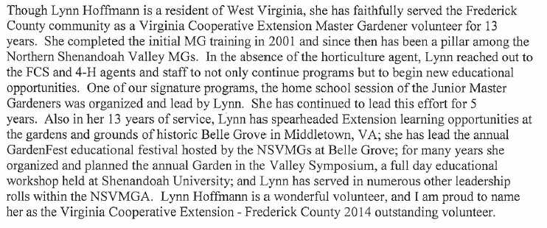
Old Business
The 2014 Board members were recognized for their contributions and leadership:
Bob Carlton, President; Ginny Smith, Vice President; Suzanne Boag, Secretary; and Lee Demko, Treasurer.
The county coordinators were recognized: Emily Wickham, Frederick County; Elke Thomas, Lesley and Tom Mack, Page County; and Katherine Rindt, Warren County. Also, Carolyn Wilson will be stepping down as Shenandoah County coordinator. Her accomplishments, including 5,000 volunteer hours, were recognized by the membership. Helen Lake presented the following tribute written by Sarah Kohrs to honor Carolyn’s contributions to Master Gardeners:
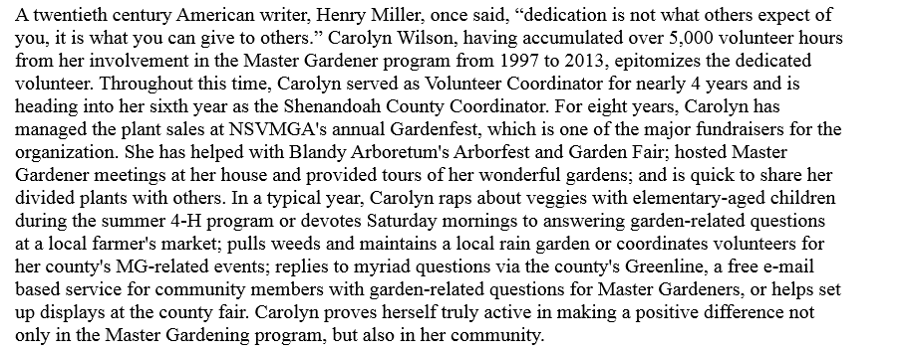Sharon Bradshaw will be the new Shenandoah Co. coordinator. Mary Craig will also be stepping down as Clarke County coordinator. Ginny Smith will replace her at that position. She will continue to be the photographer, our historian, and Membership chair.
Cy Haley will be stepping down from the Board. Mark Sutphin was presented with a gift certificate to Joe’s Steakhouse for his contributions and support.
Belle Grove will be decorated on December 9.
Raffle tickets were distributed, and winners chosen to receive planters created by Susan Garrett.
New Business
2015 Budget: The 2015 Budget was presented (reflecting 15 students for next year’s class). Rich Howell made a motion to accept the budget as presented, and Charles Newton seconded it. Membership voted to accept the budget (a quorum was present).
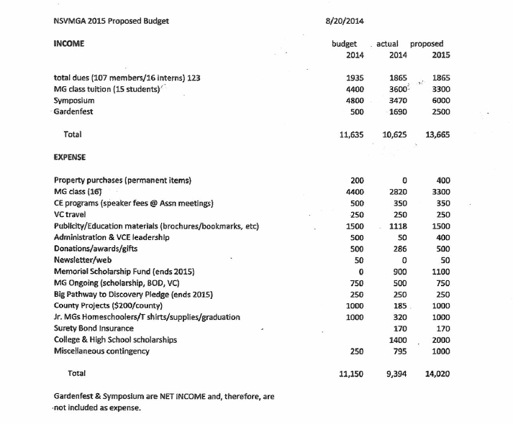
Amendment Guidelines for Reimbursal: Cy Haley made a motion to accept the guidelines as presented, and Lee Demko seconded it. Membership (quorum present) voted to accept the guidelines.
2015 Board: Susan Garret, President; Vice President, Karen Brill; Treasurer, Lee Demko; and Secretary, Kris Behrends. Frank Baxter made a motion to accept the nominations, and Rich Howell seconded to accept the nominations. Membership voted to accept the nominations submitted (quorum present).
Adjournment
Frank Baxter made a motion to adjourn, Rich Howell seconded, and the meeting was adjourned at 4 p.m.
Respectfully submitted,

Kris Behrends
Secretary, NSVMGA
NSVMGA ATTENDANCE
November 16, 2014
Frank Baxter (A) Helen Lake (A)
Kris Behrends (A) June Newcomb (A)
Elizabeth Bevan (A) Charles Newton (A)
Suzanne Boag (A) Belinda Palmer (A)
Sharon Bradshaw (A) Carol Pittillo (A)
Karen Bill (A) Brenda Powell (A)
Joy Brunk (I) Ginny Reed (A)
Dawn Buehler (I) Katherine Rindt (A)
Marsha Burd (A) Ginny Smith (A)
Bob Carlton (A) Stacey Smith (A)
Mary Carlton (H) Richard Stromberg (A)
Laurie Cocina (A) Elke Thomas (A)
Mary Craig (A) Cyndi Walsh (A)
Claire DeMasi (A) Emily Wickham (A)
Lee Demko (A) Carolyn Wilson (A)
Donna Funk-Smith (A)
Susan Garrett (A) Mark Sutphin
Lynda Hale (A)
Sally Hale (A) Total Active Members = 87
Cynthia Haley (A) Active Members Present = 38
Larry Haun (A) Quorum = 21
Sandra Himmelright (A)
Pam Hough (A)
Rich Howell (A)
Angie Hutchinson (A)
Janet Keithley (A)

